Use Case Specification
Building Materials Warehouse Management System (BMWMS) – Report 3

Version | 1.0
Date | 01/06/2026

Change Log
Version | Date | Author | Summary
1.0 | 01/06/2026 | Tran Duc Thang | Initial draft

Table of Contents
Change Log 1
Table of Contents 2
Glossary 5
Conventions & Notation 6
Step Notation 8
UC Types at a Glance 8
UC-01: View Warehouse List 9
Main Flow 9
Alternative Flows 10
Business Rules 10
Request Fields — Warehouse Search Criteria 10
Allowed Roles 11
Verification Criteria 11
UC-02: Create Warehouse 12
Main Flow 12
Alternative Flows 13
Business Rules 13
Request Fields — Warehouse Search Criteria 14
Allowed Roles 14
Verification Criteria 14
UC-03: Update Warehouse 15
Main Flow 16
Alternative Flows 16
Business Rules 17
Request Fields — Warehouse Search Criteria 17
Allowed Roles 18
Verification Criteria 18
UC-04: View Warehouse Detail 18
Main Flow 19
Alternative Flows 20
Business Rules 20
Request Fields — Warehouse Detail Request 20
Allowed Roles 21
Verification Criteria 21
UC-05: Deactivate Warehouse 22
Main Flow 23
Alternative Flows 23
Business Rules 24
Request Fields — Warehouse Detail Request 24
Response Fields 24
Allowed Roles 25
Verification Criteria 25
UC-06: View Storage Location List 26
Main Flow 27
Alternative Flows 27
Business Rules 28
Request Fields — Warehouse Detail Request 28
Response Fields 28
Allowed Roles 29
Verification Criteria 29
UC-07: Create Storage Location 30
Main Flow 31
Alternative Flows 31
Business Rules 32
Request Fields — Warehouse Detail Request 32
Allowed Roles 32
Verification Criteria 32
UC-08: Update Storage Location 33
Main Flow 34
Alternative Flows 35
Business Rules 35
Request Fields — Warehouse Detail Request 36
Allowed Roles 36
Verification Criteria 36
UC-09: View Storage Location Detail 37
Main Flow 38
Alternative Flows 38
Business Rules 39
Request Fields — Storage Location Detail Request 39
Response Fields 39
Allowed Roles 40
Verification Criteria 40
UC-10: Locate Product 40
Main Flow 41
Alternative Flows 41
Business Rules 41
Request Fields — Storage Location Detail Request 41
Response Fields 41
Allowed Roles 42
Verification Criteria 42
UC-11: View Product List 42
Main Flow 43
Alternative Flows 44
Business Rules 44
Request Fields — Storage Location Detail Request 45
Response Fields 45
Allowed Roles 45
Verification Criteria 45
UC-12: Create Product 46
Main Flow 47
Alternative Flows 48
Business Rules 48
Request Fields — Create Product Request 49
On success: The product is created successfully and displayed on the Product Detail screen. 50
Allowed Roles 50
Verification Criteria 50

Glossary
Guidance
Define domain terms a developer who knows technology but not this business domain might misunderstand. Focus on: terms with multiple meanings, abbreviations, domain concepts that differ from everyday meaning.

Term | Definition
BMWMS | Building Materials Warehouse Management System used to manage warehouse operations, inventory, and logistics activities.
Warehouse | A physical storage facility where products and materials are stored.
Storage Location | A specific storage position within a warehouse used to store products.
Area | A storage zone within a warehouse.
Shelf | A rack or shelf used to organize products within a storage area.
Bin | The smallest storage unit where products are physically placed.
Product | An item, material, or inventory unit managed by the system.
Product Group | A category used to classify products with similar characteristics.
Product Attribute | A characteristic that describes a product, such as size, color, material, or specification.
Unit of Measure (UoM) | The measurement unit used for a product, such as Piece, Box, Meter, Kilogram, or Ton.
Barcode | A machine-readable code used to uniquely identify a product.
Supplier | A company or individual that provides products or materials to the warehouse.
Supplier Product | A product that is supplied by a specific supplier.
Inventory | The current quantity of products available in the warehouse.
Inventory Transaction | A record of any inventory movement that changes stock quantity.
Inbound Voucher | A document used to record incoming goods received into the warehouse.
Receiving | The process of accepting and verifying goods received from suppliers.
Putaway | The process of moving received goods into designated storage locations.
Outbound Voucher | A document used to record goods issued from the warehouse.
Picking | The process of collecting products from storage locations for shipment or transfer.
Shipping | The process of delivering goods to customers or recipients.
Stocktake | The process of physically counting inventory to verify stock accuracy.
Stock Adjustment | An inventory correction performed after identifying discrepancies.

Conventions & Notation
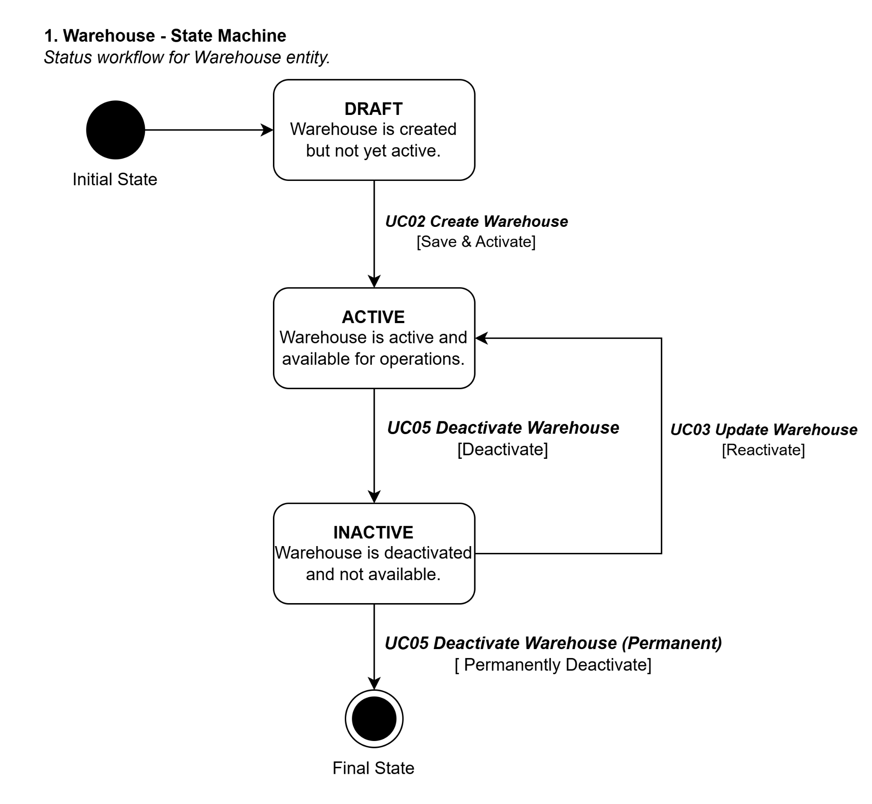
{{WAREHOUSE}} status workflow
DRAFT → ACTIVE (System Administrator, UC02 Create Warehouse)
ACTIVE → INACTIVE (System Administrator, UC05 Deactivate Warehouse)
INACTIVE → ACTIVE (System Administrator, UC03 Update Warehouse)
[ACTIVE]
[INACTIVE]
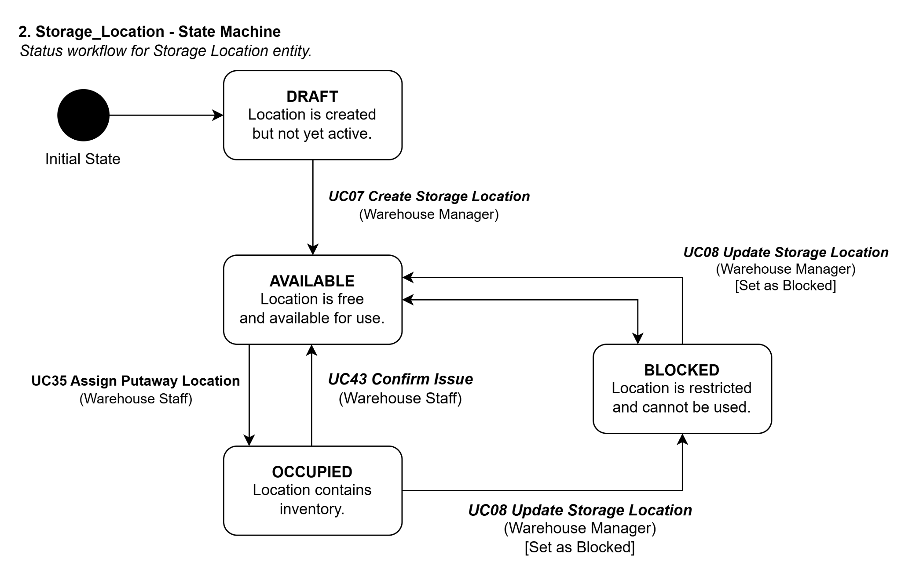
{{STORAGE_LOCATION}} status workflow
DRAFT → AVAILABLE (Warehouse Manager, UC07 Create Storage Location)
AVAILABLE → OCCUPIED (Warehouse Staff, UC35 Assign Putaway Location)
OCCUPIED → AVAILABLE (Warehouse Staff, UC43 Confirm Issue)
AVAILABLE → BLOCKED (Warehouse Manager, UC08 Update Storage Location)
OCCUPIED → BLOCKED (Warehouse Manager, UC08 Update Storage Location)
BLOCKED → AVAILABLE (Warehouse Manager, UC08 Update Storage Location)
[AVAILABLE]
[OCCUPIED]
[BLOCKED]
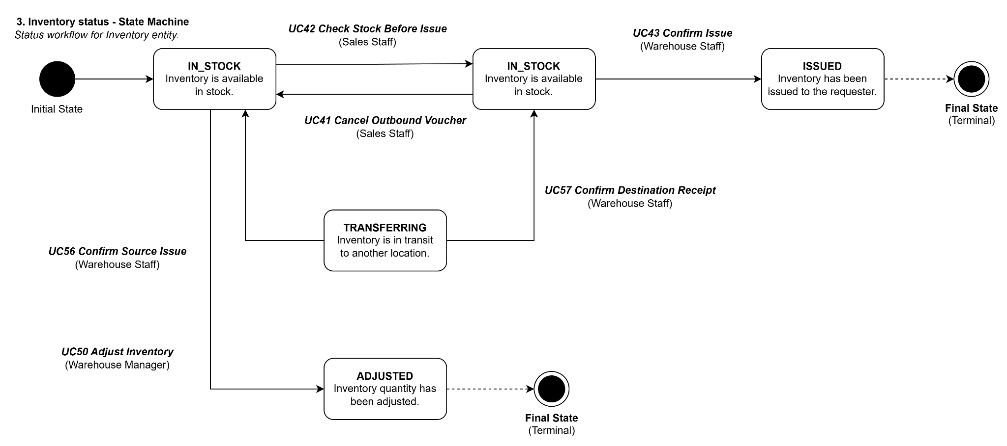
{{INVENTORY}} status workflow
IN_STOCK → RESERVED (Sales Staff, UC42 Check Stock Before Issue)
RESERVED → IN_STOCK (Sales Staff, UC41 Cancel Outbound Voucher)
RESERVED → ISSUED (Warehouse Staff, UC43 Confirm Issue)
IN_STOCK → TRANSFERRING (Warehouse Staff, UC56 Confirm Source Issue)
TRANSFERRING → IN_STOCK (Warehouse Staff, UC57 Confirm Destination Receipt)
IN_STOCK → ADJUSTED (Warehouse Manager, UC50 Adjust Inventory)
[ISSUED]
[ADJUSTED]
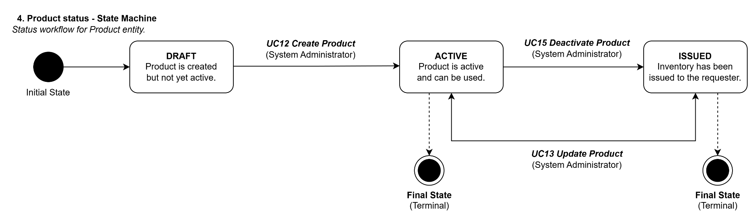
{{PRODUCT}} status workflow
DRAFT → ACTIVE (System Administrator, UC12 Create Product)
ACTIVE → INACTIVE (System Administrator, UC15 Deactivate Product)
INACTIVE → ACTIVE (System Administrator, UC13 Update Product)
[ACTIVE]
[INACTIVE]
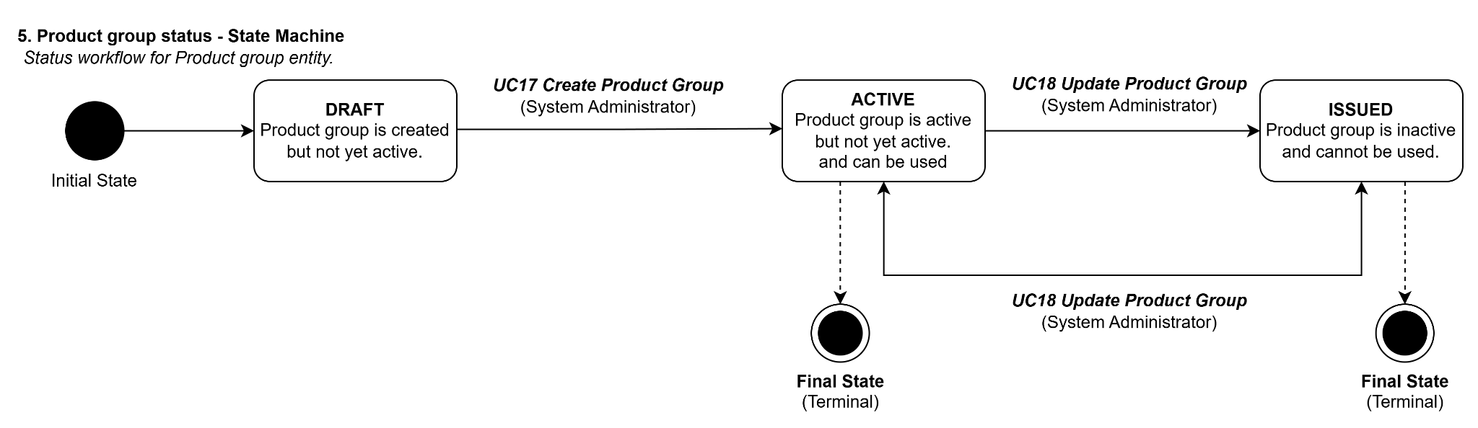
{{PRODUCT_GROUP}} status workflow
DRAFT → ACTIVE (System Administrator, UC17 Create Product Group)
ACTIVE → INACTIVE (System Administrator, UC18 Update Product Group)
INACTIVE → ACTIVE (System Administrator, UC18 Update Product Group)
[ACTIVE]
[INACTIVE]
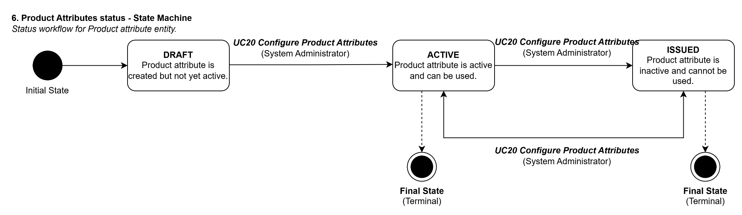
{{PRODUCT_ATTRIBUTE}} status workflow
DRAFT → ACTIVE (System Administrator, UC20 Configure Product Attributes)
ACTIVE → INACTIVE (System Administrator, UC20 Configure Product Attributes)
INACTIVE → ACTIVE (System Administrator, UC20 Configure Product Attributes)
[ACTIVE]
[INACTIVE]
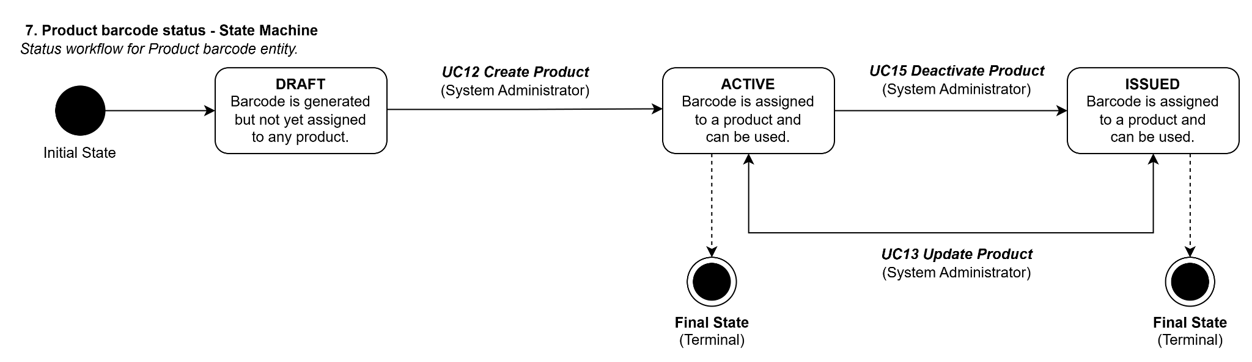
{{PRODUCT_BARCODE}} status workflow
GENERATED → ASSIGNED (System Administrator, UC12 Create Product)
ASSIGNED → DISABLED (System Administrator, UC15 Deactivate Product)
DISABLED → ASSIGNED (System Administrator, UC13 Update Product)
[ASSIGNED]
[DISABLED]
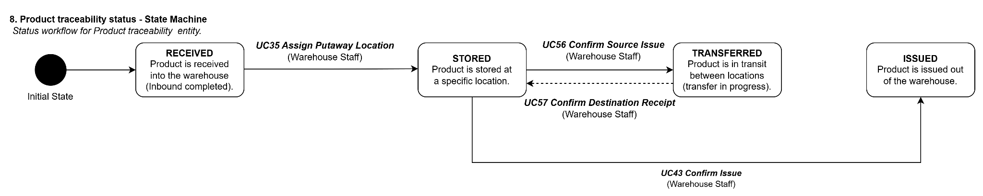
{{PRODUCT_TRACEABILITY}} status workflow
RECEIVED → STORED (Warehouse Staff, UC35 Assign Putaway Location)
STORED → TRANSFERRED (Warehouse Staff, UC56 Confirm Source Issue)
TRANSFERRED → STORED (Warehouse Staff, UC57 Confirm Destination Receipt)
STORED → ISSUED (Warehouse Staff, UC43 Confirm Issue)
[ISSUED — terminal]

Step Notation
Symbol | Meaning
[U] | The person takes an action (clicks, fills in, submits)
[S] | The system takes an action (checks, saves, sends, calculates)
[E] | The external system takes an action (sends data, requests information)
[J] | The scheduled process runs (triggered by time or event)
AF-xx | Alternative Flow — what happens when the main flow deviates
BR-xx | Business Rule — a condition or constraint the system must enforce

UC Types at a Glance
Aspect | UI-type | API-type | JOB-type
Who starts it | A person using a screen | An external system sending data | A schedule or internal event
Who can access | Named roles from PRD §2 | Authenticated external systems | Internal only — no external access
What it receives | Form input from a screen | A structured data payload | A trigger signal or event data
What it returns | A screen, message, or updated view | A structured response (success or failure) | No response — outcome is a side effect
Auth details | See TDS §4 | See TDS §4 | Not applicable

UC-01: View Warehouse List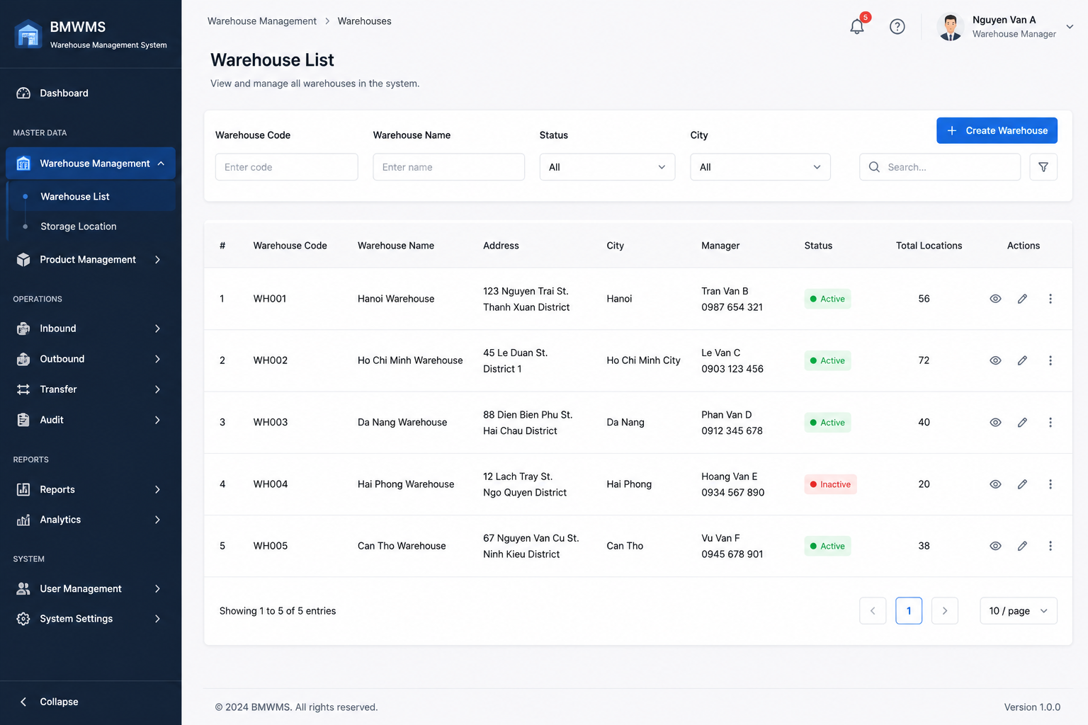

Field | Value
Type | UI
Primary Actor | Warehouse Manager
Secondary Actor(s) | Warehouse Staff
Module | Warehouse Management
FT-ID Ref | F01.01
Depends On | —
Preconditions | User is logged into the system and has permission to access Warehouse Management.
Postconditions | Warehouse list is displayed according to search and filter conditions.

Main Flow
- [U] User opens the Warehouse List screen.
- [S] System retrieves all warehouses available to the user.
- [S] System displays warehouse information including Warehouse Code, Warehouse Name, Address, City, Manager, Status and Total Locations.
- [U] User enters search criteria or selects filter conditions.
- [S] System validates filter values and executes search — see BR-01, BR-02.
- [S] System refreshes the warehouse list and displays matching records.
- [U] User navigates through pages or changes page size.
- [S] System displays the corresponding warehouse records.

Alternative Flows
AF-01 — No Matching Warehouse
At step 5, no warehouse satisfies the search criteria.
The system displays an empty result set with the message:
"No warehouse found."
AF-02 — Invalid Filter Value
At step 5, the user enters an unsupported filter value.
The system ignores the invalid filter and displays a validation message.
AF-03 — No Warehouse Available
At step 2, no warehouse records exist in the system.
The system displays an empty warehouse list and allows the user to create a new warehouse.

Business Rules
BR-01

The system shall support filtering by Warehouse Code.

BR-02

The system shall support filtering by Warehouse Name, Status and City.

BR-03

The warehouse list shall be displayed in paginated format.

BR-04

Inactive warehouses shall remain visible in the list.

BR-05

Only warehouses accessible to the logged-in user shall be displayed.

Request Fields — Warehouse Search Criteria
Field | Type | Rule
Warehouse Code | Text | Optional. Partial matching allowed.
Warehouse Name | Text | Optional. Partial matching allowed.
Status | Text | Optional. Active, Inactive or All.
City | Text | Optional. Select from available cities.
Search Keyword | Text | Optional. Searches Warehouse Code and Warehouse Name.
Page Number | Number | Optional. Default value is 1.
Page Size | Number | Optional. Default value is 10.

On success: The warehouse list is refreshed and displays all matching warehouse records.

Allowed Roles
- Warehouse Manager
- Warehouse Staff
- System Administrator

Verification Criteria
Given
- Warehouse records exist in the system
- The user has permission to access Warehouse Management
When
- The user opens the Warehouse List screen
- Or applies search and filter criteria
Then
- The system displays matching warehouse records
- And pagination information is displayed correctly
- And inactive warehouses are clear mn ly identified

Additional scenarios to cover in tests:
- Search warehouse by Warehouse Code.
- Filter warehouse by Status = Active.
- Filter warehouse by City.
- Search returns no result.
- Navigate between pages.
- Change page size from 10 to 20 records.

UC-02: Create Warehouse
UI-type block
Copy this block for each UI-type use case. Sections: Header | Main Flow | Alternative Flows | Business Rules | Request Fields | Allowed Roles | Verification Criteria
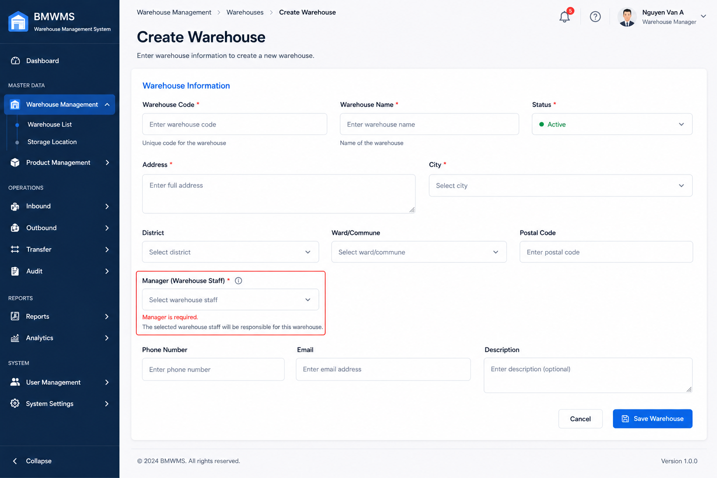

Field | Value
Type | UI
Primary Actor | Warehouse Manager
Secondary Actor(s) | System Administrator
Module | Warehouse Management
FT-ID Ref | F01.01
Depends On | —
Preconditions | User is logged in and has permission to create warehouses.
Postconditions | A new warehouse is created and available for warehouse operations.

Main Flow
- [U] User clicks Create Warehouse on the Warehouse List screen.
- [S] System displays the Create Warehouse form.
- [U] User enters warehouse information and submits the form.
- [S] System validates the input — see BR-01, BR-02, BR-03.
- [S] System creates a new Warehouse record with status Active.
- [S] System records the creator and creation timestamp.
- [S] System displays a success message.
- [S] System redirects the user to the Warehouse Detail screen.

Alternative Flows
AF-01 — Duplicate Warehouse Code
At step 4, the system finds that the Warehouse Code already exists.
The warehouse is not created.
The user remains on the form and sees:
"Warehouse Code already exists."
AF-02 — Required Information Missing
At step 4, one or more mandatory fields are empty.
The warehouse is not created.
The system highlights invalid fields and displays validation messages.
AF-03 — User Cancels Creation
At step 3, the user selects Cancel.
The system discards unsaved changes and returns to the Warehouse List screen.

Business Rules
BR-01

Warehouse Code must be unique across the entire system.

BR-02

Warehouse Code and Warehouse Name are mandatory.

BR-03

Warehouse Name must not exceed 255 characters.

BR-04

New warehouses are created with status Active by default.

BR-05

A warehouse manager may be assigned during warehouse creation.

BR-06

The system shall record creation date and creator information automatically.

Request Fields — Warehouse Search Criteria
Field | Type | Rule
Warehouse Code | Text | Required. Unique. Maximum 50 characters.
Warehouse Name | Text | Required. Maximum 255 characters.
Address | Text | Required. Maximum 500 characters.
City | Text | Required. Select from available cities.
Warehouse Manager | Text | Optional. Must be an active user.
Contact Phone | Text | Optional. Valid phone number format.
Description | Text | Optional. Maximum 1000 characters.
Status | Yes/No | Default Active.

On success: The warehouse is created successfully and the user is redirected to the Warehouse Detail screen.

Allowed Roles
- Warehouse Manager
- System Administrator

Verification Criteria
Given
- The user is logged in
- The user has warehouse creation permission
When
- The user submits valid warehouse information
Then
- A new warehouse record is created
- And the warehouse status is Active
- And creator information is recorded
- And the warehouse appears in the Warehouse List

Additional scenarios to cover in tests:
- Create warehouse with valid information.
- Create warehouse using an existing Warehouse Code.
- Submit form with missing required fields.
- Submit form with Warehouse Name exceeding maximum length.
- Cancel warehouse creation before saving.
- Verify warehouse appears in Warehouse List after creation.

UC-03: Update Warehouse
UI-type block
Copy this block for each UI-type use case. Sections: Header | Main Flow | Alternative Flows | Business Rules | Request Fields | Allowed Roles | Verification Criteria
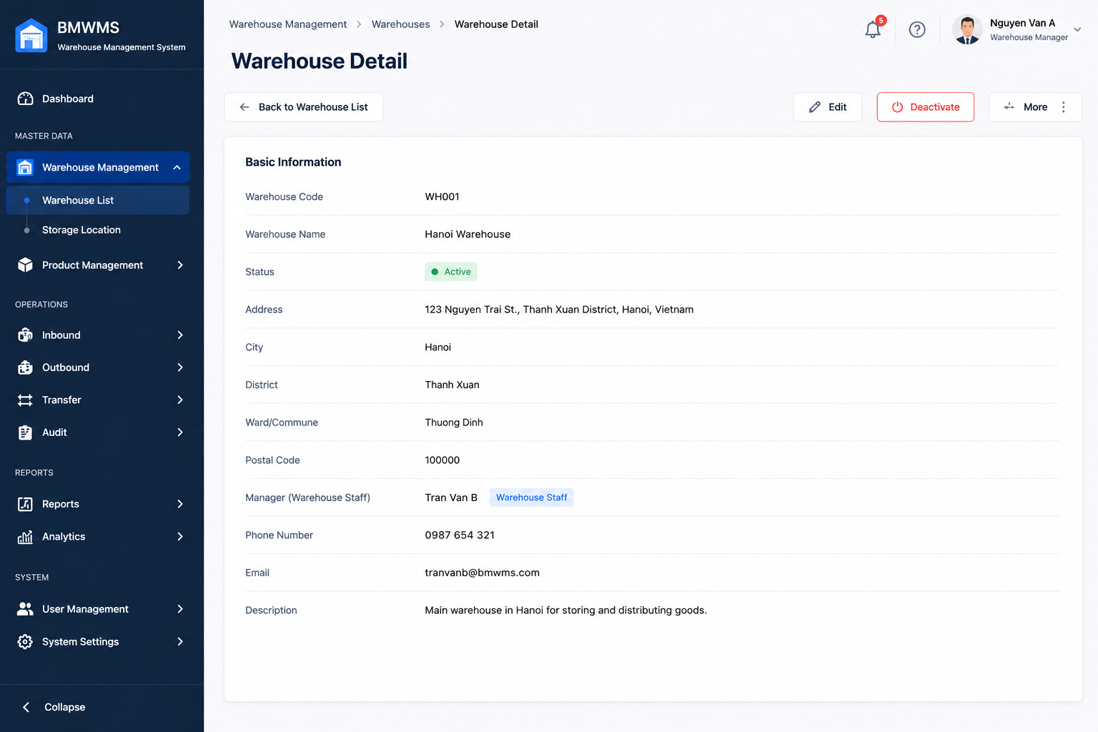

Field | Value
Type | UI
Primary Actor | Warehouse Manager
Secondary Actor(s) | System Administrator
Module | Warehouse Management
FT-ID Ref | F01.01
Depends On | UC-01 Create Warehouse
Preconditions | User is logged in and has warehouse update permission. The warehouse already exists.
Postconditions | Warehouse information is updated successfully.

Main Flow
- [U] User selects a warehouse from the Warehouse List.
- [U] User clicks the Edit button.
- [S] System displays the Warehouse Edit form with current warehouse information.
- [U] User modifies warehouse information.
- [U] User clicks Save.
- [S] System validates the input — see BR-01, BR-02, BR-03.
- [S] System updates the Warehouse record.
- [S] System records modification date and modifier information.
- [S] System displays a success message.
- [S] System refreshes warehouse information on the Warehouse Detail screen.

Alternative Flows
AF-01 — Warehouse Not Found
At step 3, the selected warehouse no longer exists.
The system displays:
"Warehouse not found."
The user is redirected to the Warehouse List screen.
AF-02 — Duplicate Warehouse Code
At step 6, the updated Warehouse Code already belongs to another warehouse.
The warehouse is not updated.
The user remains on the form and sees:
"Warehouse Code already exists."
AF-03 — Invalid Information
At step 6, one or more fields fail validation.
The warehouse is not updated.
The system highlights invalid fields and displays validation messages.
AF-04 — User Cancels Update
At step 4, the user clicks Cancel.
The system discards all unsaved changes and returns to the Warehouse Detail screen.

Business Rules
BR-01

Warehouse Code must remain unique across the system.

BR-02

Warehouse Name cannot be empty.

BR-03

Only Active users can be assigned as Warehouse Manager.

BR-04

Warehouse Code cannot be changed if inventory transactions already exist for the warehouse.

BR-05

All warehouse update activities must be recorded in the audit log.

BR-06

The system shall automatically update Last Modified Date and Last Modified By.

Request Fields — Warehouse Search Criteria
Field | Type | Rule
Warehouse Code | Text | Required. Unique. Read-only if inventory transactions exist.
Warehouse Name | Text | Required. Maximum 255 characters.
Address | Text | Required. Maximum 500 characters.
City | Text | Required. Select from available cities.
Warehouse Manager | Text | Optional. Must be an active user.
Contact Phone | Text | Optional. Valid phone number format.
Description | Text | Optional. Maximum 1000 characters.
Status | Yes/No | Active or Inactive.

On success: The warehouse information is updated successfully and the latest information is displayed.

Allowed Roles
- Warehouse Manager
- System Administrator

Verification Criteria
Given
- The user is logged in
- The warehouse exists
- The user has warehouse update permission
When
- The user submits valid warehouse changes
Then
- The warehouse record is updated
- And modification information is recorded
- And updated information is displayed immediately

Additional scenarios to cover in tests:

- Update warehouse name successfully.
- Update warehouse address successfully.
- Assign a new warehouse manager.
- Update using an existing Warehouse Code.
- Attempt to assign an inactive user as manager.
- Cancel update without saving.
- Verify audit log is created after update.
- Verify Last Modified Date is updated correctly.

UC-04: View Warehouse Detail
UI-type block
Copy this block for each UI-type use case. Sections: Header | Main Flow | Alternative Flows | Business Rules | Request Fields | Allowed Roles | Verification Criteria


Field | Value
Type | UI
Primary Actor | Warehouse Manager
Secondary Actor(s) | Warehouse Staff, System Administrator
Module | Warehouse Management
FT-ID Ref | F01.01
Depends On | UC-01 View Warehouse List
Preconditions | User is logged in and has warehouse viewing permission. Warehouse exists in the system.
Postconditions | Warehouse detail information is displayed.

Main Flow
- [U] User accesses the Warehouse List screen.
- [U] User selects a warehouse.
- [U] User clicks the View button.
- [S] System retrieves warehouse information.
- [S] System retrieves related storage location information.
- [S] System retrieves current inventory summary for the warehouse.
- [S] System displays Warehouse Detail information.
- [S] System displays storage location statistics and inventory summary.

Alternative Flows
AF-01 — Warehouse Not Found
At step 4, the selected warehouse no longer exists.
The system displays:
"Warehouse not found."
The user is redirected to the Warehouse List screen.
AF-02 — User Has No Permission
At step 3, the user does not have permission to view warehouse details.
The system displays:
"You do not have permission to access this warehouse."
AF-03 — No Storage Locations
At step 5, no storage locations exist for the warehouse.
The system displays warehouse information and shows:
"No storage locations available."
AF-04 — No Inventory Available
At step 6, the warehouse contains no inventory.
The system displays inventory summary with zero values.

Business Rules
BR-01
Users can only view warehouses they are authorized to access.

BR-02
Warehouse information displayed must reflect the latest saved data.

BR-03
Inventory statistics must be calculated in real time.

BR-04
Inactive warehouses remain viewable for audit and reporting purposes.

BR-05
Warehouse detail information is read-only on the View screen.

Request Fields — Warehouse Detail Request
Field | Type | Rule
Warehouse ID | Number | Required. Must exist in the system.
Warehouse Code | Text | Display only.
Warehouse Name | Text | Display only.
Address | Text | Display only.
City | Text | Display only.
Warehouse Manager | Text | Display only.
Contact Phone | Text | Display only.
Status | Text | Active or Inactive.
Created Date | Date | Display only.
Last Modified Date | Date | Display only.
Total Storage Locations | Number | Calculated by system.
Total Inventory Quantity | Number | Calculated by system.
Description | Text | Display only.

On success: Warehouse detail information, storage location statistics, and inventory summary are displayed.

Allowed Roles
- Warehouse Manager
- Warehouse Staff
- System Administrator
- Purchasing Staff (View Only)
- Sales Staff (View Only)

Verification Criteria
Given
- The user is logged in
- The warehouse exists
- The user has viewing permission
When
- The user selects a warehouse and clicks View
Then
- Warehouse details are displayed
- Storage location statistics are displayed
- Inventory summary is displayed

Additional scenarios to cover in tests:

- View an active warehouse.
- View an inactive warehouse.
- View warehouse with storage locations.
- View warehouse without storage locations.
- View warehouse with inventory.
- View warehouse without inventory.
- Attempt to view a warehouse without permission.
- Attempt to view a deleted or non-existing warehouse.
- Verify inventory summary values are correct.
- Verify storage location totals are correct.

UC-05: Deactivate Warehouse
UI-type block
Copy this block for each UI-type use case. Sections: Header | Main Flow | Alternative Flows | Business Rules | Request Fields | Allowed Roles | Verification Criteria
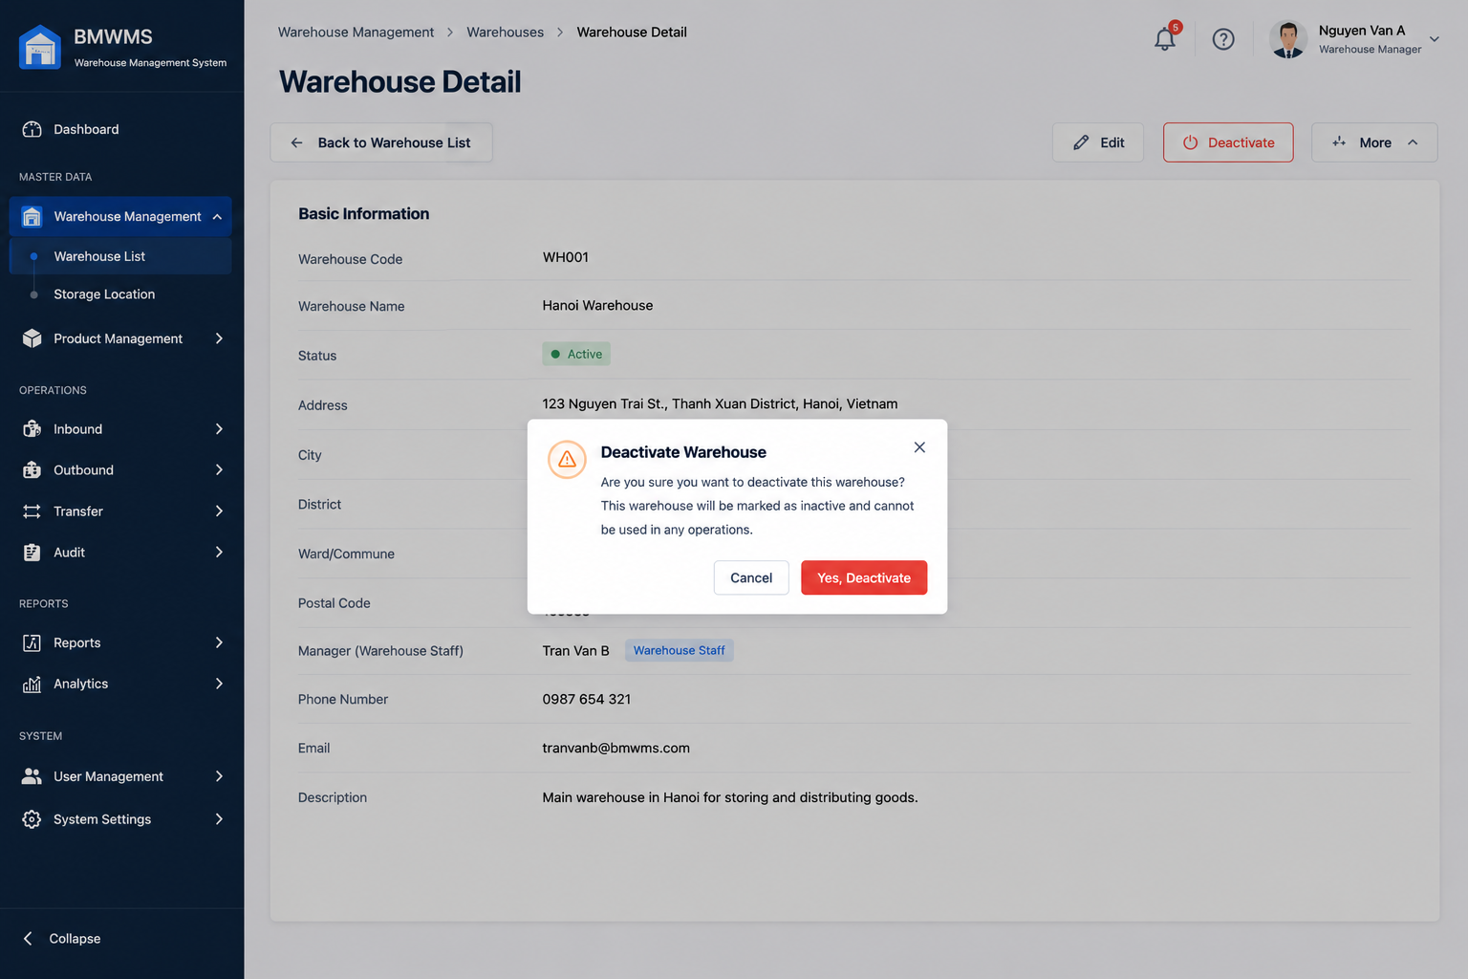

Field | Value
Type | UI
Primary Actor | Warehouse Manager
Secondary Actor(s) | System Administrator
Module | Warehouse Management
FT-ID Ref | F01.01
Depends On | UC-01 View Warehouse List
Preconditions | User is logged in. User has warehouse management permission. Warehouse exists and is currently Active.
Postconditions | Warehouse status is changed from Active to Inactive. Warehouse is no longer available for new warehouse operations.

Main Flow
- [U] User accesses the Warehouse List screen.
- [U] User selects an active warehouse.
- [U] User clicks the Deactivate action.
- [S] System displays a confirmation dialog.
- [U] User confirms the deactivation.
- [S] System validates warehouse status — see BR-01, BR-02.
- [S] System changes the warehouse status to Inactive.
- [S] System records the deactivation activity in the audit log.
- [S] System displays a success message.
- [S] System refreshes the Warehouse List.

Alternative Flows
AF-01 — User Cancels Action
At step 5, the user selects Cancel.
The system closes the confirmation dialog.
No changes are made.
AF-02 — Warehouse Already Inactive
At step 6, the warehouse status is already Inactive.
The system displays:
"Warehouse is already inactive."
No changes are made.
AF-03 — Warehouse Contains Active Transactions
At step 6, the warehouse is referenced by pending inbound, outbound, transfer, or stocktaking transactions.
The system displays:
"Warehouse cannot be deactivated because active transactions exist."
No changes are made.
AF-04 — Insufficient Permission
At step 3, the user does not have deactivation permission.
The system displays:
"You do not have permission to deactivate this warehouse."

Business Rules
BR-01
Only Active warehouses can be deactivated.

BR-02
A warehouse with pending operational transactions cannot be deactivated.

BR-03
Deactivation changes warehouse status only; warehouse data is retained.

BR-04
Inactive warehouses cannot be selected when creating inbound, outbound, transfer, or stocktaking transactions.

BR-05
All warehouse deactivation activities must be recorded in the audit log.

BR-06
Only Warehouse Managers and System Administrators may deactivate warehouses.

Request Fields — Warehouse Detail Request
Field | Type | Rule
Warehouse ID | Number | Required. Must exist in the system.
Confirmation | Yes/No | Must be Yes to proceed.
Deactivation Reason | Text | Optional. Maximum 500 characters.

Response Fields
Field | Type | Rule
Warehouse ID | Number | Display only.
Warehouse Code | Text | Display only.
Warehouse Name | Text | Display only.
Previous Status | Text | Active.
New Status | Text | Inactive.
Deactivated By | Text | Current user.
Deactivated Date | Date | System generated.

On success: Warehouse status is updated to Inactive and the warehouse is removed from future operational selections.

Allowed Roles
- Warehouse Manager
- System Administrator

Verification Criteria
Given
- The user is logged in
- The warehouse exists
- The warehouse is Active
- No pending transactions exist
When
- The user confirms warehouse deactivation
Then
- Warehouse status becomes Inactive
- Audit log is created
- Success message is displayed

Additional scenarios to cover in tests:

- Deactivate a warehouse with no active transactions.
- Attempt to deactivate a warehouse with pending inbound orders.
- Attempt to deactivate a warehouse with pending outbound orders.
- Attempt to deactivate a warehouse with pending transfer requests.
- Cancel the deactivation confirmation.
- Attempt to deactivate an already inactive warehouse.
- Verify warehouse remains visible in historical reports.
- Verify inactive warehouse cannot be selected during transaction creation.
- Verify audit log is generated correctly.
- Verify unauthorized users cannot deactivate warehouses.

UC-06: View Storage Location List
UI-type block
Copy this block for each UI-type use case. Sections: Header | Main Flow | Alternative Flows | Business Rules | Request Fields | Allowed Roles | Verification Criteria
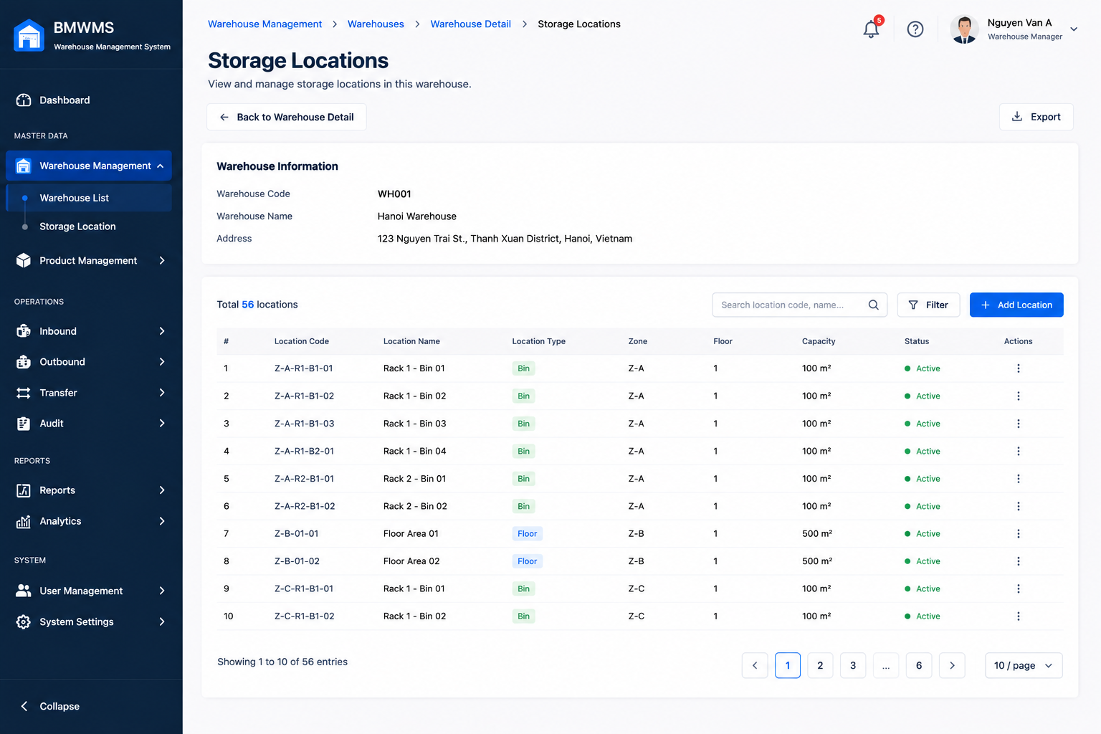

Field | Value
Type | UI
Primary Actor | Warehouse Manager
Secondary Actor(s) | Warehouse Staff, System Administrator
Module | Warehouse Management
FT-ID Ref | F01.02
Depends On | UC-04 View Warehouse Detail
Preconditions | User is logged in and has permission to access Storage Location Management. At least one warehouse exists.
Postconditions | Storage Location List is displayed according to selected warehouse and search criteria.

Main Flow
- [U] User navigates to a warehouse detail screen.
- [U] User opens the Storage Location tab or selects Storage Location Management.
- [S] System retrieves all storage locations belonging to the selected warehouse.
- [S] System displays storage location information including Location Code, Location Name, Location Type, Capacity, Utilization, and Status.
- [U] User enters search criteria or filter conditions.
- [S] System validates search conditions — see BR-01, BR-02.
- [S] System refreshes the storage location list.
- [S] System displays matching storage locations.
- [U] User navigates through pages or changes page size.
- [S] System displays the corresponding storage location records.

Alternative Flows
AF-01 — No Storage Locations Found
At step 7, no storage location matches the search criteria.
The system displays:
"No storage locations found."
AF-02 — Warehouse Has No Storage Locations
At step 3, the selected warehouse does not contain any storage locations.
The system displays an empty list and allows authorized users to create a new storage location.
AF-03 — Invalid Search Criteria
At step 6, one or more filter values are invalid.
The system displays a validation message and keeps the current search conditions.
AF-04 — Warehouse Not Found
At step 3, the selected warehouse no longer exists.
The system displays:
"Warehouse not found."
The user is redirected to the Warehouse List screen.

Business Rules
BR-01
The system shall support searching by Location Code.

BR-02
The system shall support filtering by Location Type and Status.

BR-03
Storage locations shall only be displayed within the selected warehouse.

BR-04
Inactive storage locations shall remain visible for audit and reporting purposes.

BR-05
Storage utilization percentage shall be calculated automatically based on current inventory quantity and configured capacity.

BR-06
The list shall support pagination.

Request Fields — Warehouse Detail Request
Field | Type | Rule
Warehouse ID | Number | Required. Must exist in the system.
Location Code | Text | Optional. Partial matching allowed.
Location Name | Text | Optional. Partial matching allowed.
Location Type | Text | Optional. Zone, Rack, Shelf, Bin or All.
Status | Text | Optional. Active, Inactive or All.
Search Keyword | Text | Optional. Searches Location Code and Location Name.
Page Number | Number | Optional. Default value is 1.
Page Size | Number | Optional. Default value is 10.

Response Fields
Field | Type | Rule
Location Code | Text | Display only.
Location Name | Text | Display only.
Location Type | Text | Display only.
Capacity | Number | Display only.
Current Utilization | Number | System calculated.
Utilization Percentage | Number | System calculated.
Status | Text | Active or Inactive.

On success: Matching storage locations are displayed together with capacity and utilization information.

Allowed Roles
- Warehouse Manager
- Warehouse Staff
- System Administrator
- Purchasing Staff (View Only)
- Sales Staff (View Only)

Verification Criteria
Given
- The user is logged in
- The selected warehouse exists
- The user has permission to view storage locations
When
- The user opens the Storage Location List screen
- Or applies search and filter criteria
Then
- Storage locations belonging to the selected warehouse are displayed
- Capacity information is displayed
- Utilization information is displayed
- Pagination works correctly

Additional scenarios to cover in tests:

- View storage locations of a warehouse.
- Search by Location Code.
- Search by Location Name.
- Filter by Location Type.
- Filter by Status.
- View a warehouse with no storage locations.
- Search with no matching records.
- Navigate through multiple pages.
- Verify utilization percentage calculation.
- Verify inactive locations are displayed correctly.

UC-07: Create Storage Location
UI-type block
Copy this block for each UI-type use case. Sections: Header | Main Flow | Alternative Flows | Business Rules | Request Fields | Allowed Roles | Verification Criteria


Field | Value
Type | UI
Primary Actor | Warehouse Manager
Secondary Actor(s) | System Administrator
Module | Warehouse Management
FT-ID Ref | F01.02
Depends On | UC-04 View Warehouse Detail
Preconditions | User is logged in and has permission to manage storage locations. Target warehouse exists and is active.
Postconditions | A new storage location is created and assigned to the selected warehouse.

Main Flow
- [U] User opens the Storage Location List screen of a warehouse.
- [U] User clicks Create Storage Location.
- [S] System displays the Create Storage Location form.
- [U] User enters storage location information.
- [U] User clicks Save.
- [S] System validates the input — see BR-01, BR-02, BR-03.
- [S] System creates a new Storage Location record.
- [S] System assigns the storage location to the selected warehouse.
- [S] System records creation date and creator information.
- [S] System displays a success message.
- [S] System refreshes the Storage Location List.

Alternative Flows
AF-01 — Duplicate Location Code
At step 6, the Location Code already exists within the selected warehouse.
The storage location is not created.
The user remains on the form and sees:
"Location Code already exists in this warehouse."
AF-02 — Required Information Missing
At step 6, one or more required fields are empty.
The storage location is not created.
The system highlights invalid fields and displays validation messages.
AF-03 — Capacity Value Invalid
At step 6, Capacity is less than or equal to zero.
The storage location is not created.
The system displays:
"Capacity must be greater than zero."
AF-04 — User Cancels Creation
At step 4, the user selects Cancel.
The system discards all unsaved information and returns to the Storage Location List screen.

Business Rules
BR-01
Location Code must be unique within a warehouse.

BR-02
Location Code, Location Name, and Location Type are required.

BR-03
Capacity must be greater than zero.

BR-04
New storage locations are created with status Active by default.

BR-05
A storage location must belong to exactly one warehouse.

BR-06
The system shall automatically record creation date and creator information.

Request Fields — Warehouse Detail Request
Field | Type | Rule
Warehouse | Text | Required. Must be an active warehouse.
Location Code | Text | Required. Unique within warehouse. Maximum 50 characters.
Location Name | Text | Required. Maximum 255 characters.
Location Type | Text | Required. Zone, Rack, Shelf, Bin.
Capacity | Number | Required. Must be greater than 0.
Description | Text | Optional. Maximum 1000 characters.
Status | Yes/No | Default Active.
On success: The storage location is created successfully and appears in the Storage Location List.

Allowed Roles
- Warehouse Manager
- System Administrator

Verification Criteria
Given
- The user is logged in
- The warehouse exists and is active
- The user has storage location management permission
When
- The user submits valid storage location information
Then
- A new storage location is created
- The location is assigned to the selected warehouse
- Status is Active
- The location appears in the Storage Location List

Additional scenarios to cover in tests:

- Create a Zone location successfully.
- Create a Rack location successfully.
- Create a Shelf location successfully.
- Create a Bin location successfully.
- Create a location with an existing Location Code.
- Create a location with invalid Capacity.
- Submit form with missing required fields.
- Cancel creation before saving.
- Verify creator information is recorded.
- Verify the new location appears in the correct warehouse.

UC-08: Update Storage Location
UI-type block
Copy this block for each UI-type use case. Sections: Header | Main Flow | Alternative Flows | Business Rules | Request Fields | Allowed Roles | Verification Criteria


Field | Value
Type | UI
Primary Actor | Warehouse Manager
Secondary Actor(s) | System Administrator
Module | Warehouse Management
FT-ID Ref | F01.02
Depends On | UC-06 View Storage Location List
Preconditions | User is logged in and has permission to manage storage locations. The storage location already exists.
Postconditions | Storage location information is updated successfully.

Main Flow
- [U] User accesses the Storage Location List screen.
- [U] User selects a storage location.
- [U] User clicks the Edit button.
- [S] System displays the Storage Location Edit form with current information.
- [U] User modifies storage location information.
- [U] User clicks Save.
- [S] System validates the input — see BR-01, BR-02, BR-03.
- [S] System updates the Storage Location record.
- [S] System records modification date and modifier information.
- [S] System displays a success message.
- [S] System refreshes the Storage Location Detail screen.

Alternative Flows
AF-01 — Storage Location Not Found
At step 4, the selected storage location no longer exists.
The system displays:
"Storage Location not found."
The user is redirected to the Storage Location List screen.
AF-02 — Duplicate Location Code
At step 7, the updated Location Code already exists within the same warehouse.
The storage location is not updated.
The user remains on the form and sees:
"Location Code already exists in this warehouse."
AF-03 — Invalid Capacity
At step 7, Capacity is less than the current utilized quantity.
The storage location is not updated.
The system displays:
"Capacity cannot be less than current utilized quantity."
AF-04 — User Cancels Update
At step 5, the user clicks Cancel.
The system discards all unsaved changes and returns to the Storage Location Detail screen.

Business Rules
BR-01
Location Code must remain unique within the warehouse.

BR-02
Location Code, Location Name, and Location Type are mandatory.

BR-03
Capacity must be greater than zero.

BR-04
Capacity cannot be smaller than the quantity currently stored in the location.

BR-05
Location Type cannot be changed if inventory already exists in the location.

BR-06
All update activities must be recorded in the audit log.

BR-07
The system shall automatically update Last Modified Date and Last Modified By.

Request Fields — Warehouse Detail Request
Field | Type | Rule
Location Code | Text | Required. Unique within warehouse. Maximum 50 characters.
Location Name | Text | Required. Maximum 255 characters.
Location Type | Text | Required. Zone, Rack, Shelf, Bin. Read-only if inventory exists.
Capacity | Number | Required. Greater than 0 and not less than current utilization.
Description | Text | Optional. Maximum 1000 characters.
Status | Yes/No | Active or Inactive.
On success: Storage location information is updated successfully and the latest information is displayed

Allowed Roles
- Warehouse Manager
- System Administrator

Verification Criteria
Given
- The user is logged in
- The storage location exists
- The user has storage location management permission
When
- The user submits valid updates
Then
- The storage location record is updated
- Modification information is recorded
- Updated information is displayed immediately
Additional scenarios to cover in tests:
- Update Location Name successfully.
- Update Capacity successfully.
- Update Description successfully.
- Update using a duplicate Location Code.
- Set Capacity smaller than current utilized quantity.
- Attempt to change Location Type when inventory exists.
- Cancel update without saving.
- Verify audit log creation.
- Verify Last Modified Date is updated correctly.
- Verify updated information appears in Storage Location List and Detail screens.

UC-09: View Storage Location Detail
UI-type block
Copy this block for each UI-type use case. Sections: Header | Main Flow | Alternative Flows | Business Rules | Request Fields | Allowed Roles | Verification Criteria


Field | Value
Type | UI
Primary Actor | Warehouse Manager
Secondary Actor(s) | Warehouse Staff, System Administrator
Module | Warehouse Management
FT-ID Ref | F01.02
Depends On | UC-06 View Storage Location List
Preconditions | User is logged in and has permission to view storage location information. Storage Location exists in the system.
Postconditions | Storage Location detail information is displayed.

Main Flow
- [U] User accesses the Storage Location List screen.
- [U] User selects a storage location.
- [U] User clicks the View button.
- [S] System retrieves storage location information.
- [S] System retrieves warehouse information associated with the location.
- [S] System retrieves current inventory information stored at the location.
- [S] System calculates utilization statistics.
- [S] System displays Storage Location Detail information.
- [S] System displays inventory summary and utilization information.

Alternative Flows
AF-01 — Storage Location Not Found
At step 4, the selected storage location no longer exists.
The system displays:
"Storage Location not found."
The user is redirected to the Storage Location List screen.
AF-02 — No Inventory Stored
At step 6, no inventory exists in the selected location.
The system displays:
"No inventory currently stored."
Inventory statistics are displayed as zero.
AF-03 — User Has No Permission
At step 3, the user does not have permission to view storage location details.
The system displays:
"You do not have permission to access this storage location."
AF-04 — Warehouse Information Unavailable
At step 5, warehouse information cannot be retrieved.
The system displays the storage location information and indicates warehouse information is unavailable.

Business Rules
BR-01
Users can only view storage locations they are authorized to access.

BR-02
Storage location information displayed must reflect the latest saved data.

BR-03
Utilization percentage must be calculated based on current inventory quantity and configured capacity.

BR-04
Inactive storage locations remain viewable for audit and reporting purposes.

BR-05
Storage Location Detail is a read-only screen.

BR-06
Inventory information displayed must be updated in real time.

Request Fields — Storage Location Detail Request
Field | Type | Rule
Storage Location ID | Number | Required. Must exist in the system.

Response Fields
Field | Type | Rule
Location Code | Text | Display only.
Location Name | Text | Display only.
Location Type | Text | Display only.
Warehouse | Text | Display only.
Capacity | Number | Display only.
Current Utilization | Number | System calculated.
Utilization Percentage | Number | System calculated.
Status | Text | Active or Inactive.
Created Date | Date | Display only.
Last Modified Date | Date | Display only.
Description | Text | Display only.
On success: Storage location details, inventory summary, and utilization information are displayed.

Allowed Roles
- Warehouse Manager
- Warehouse Staff
- System Administrator
- Purchasing Staff (View Only)
- Sales Staff (View Only)

Verification Criteria
Given
- The user is logged in
- The storage location exists
- The user has viewing permission
When
- The user selects a storage location and clicks View
Then
- Storage location details are displayed
- Warehouse information is displayed
- Inventory summary is displayed
- Utilization statistics are displayed
Additional scenarios to cover in tests:
- View an active storage location.
- View an inactive storage location.
- View a storage location containing inventory.
- View a storage location with no inventory.
- Verify utilization percentage calculation.
- Verify capacity information is displayed correctly.
- Attempt to view a non-existing storage location.
- Attempt to view without permission.
- Verify inventory information is updated correctly.
- Verify warehouse information is displayed correctly.

UC-10: Locate Product
UI-type block
Copy this block for each UI-type use case. Sections: Header | Main Flow | Alternative Flows | Business Rules | Request Fields | Allowed Roles | Verification Criteria

Field | Value
Type
Primary Actor
Secondary Actor(s)
Module
FT-ID Ref
Depends On
Preconditions
Postconditions

Main Flow

Alternative Flows

Business Rules

Request Fields — Storage Location Detail Request
Field | Type | Rule

Response Fields
Field | Type | Rule
On success: Storage location details, inventory summary, and utilization information are displayed.

Allowed Roles

Verification Criteria

Additional scenarios to cover in tests:

UC-11: View Product List
UI-type block
Copy this block for each UI-type use case. Sections: Header | Main Flow | Alternative Flows | Business Rules | Request Fields | Allowed Roles | Verification Criteria
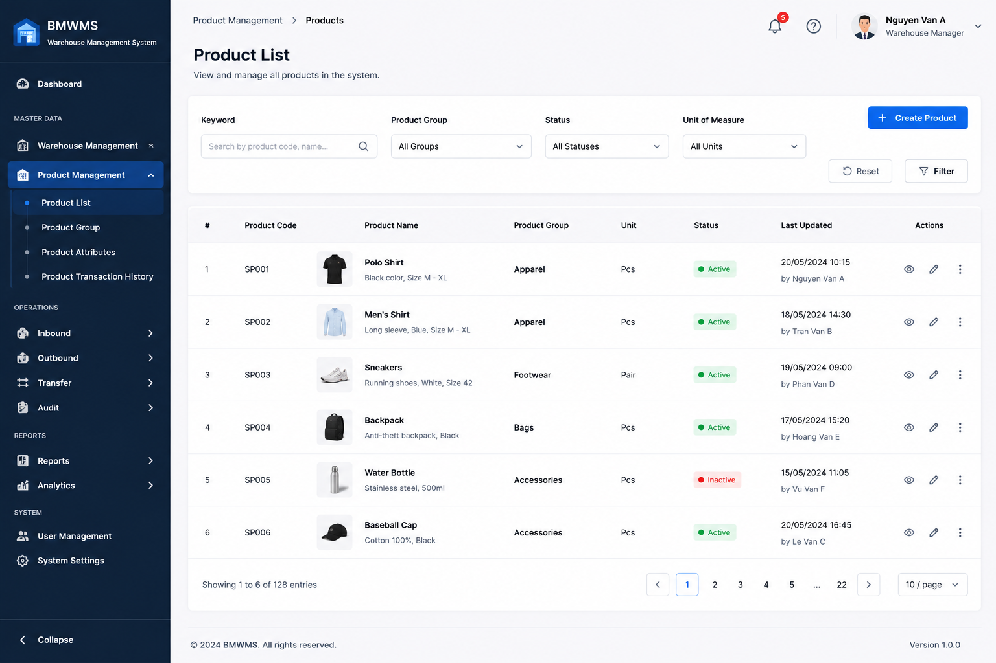

Field | Value
Type | UI
Primary Actor | Warehouse Manager
Secondary Actor(s) | Warehouse Staff, Purchasing Staff, Sales Staff
Module | Product Management
FT-ID Ref | F02.01
Depends On | —
Preconditions | User is logged in and has permission to access Product Management.
Postconditions | Product list is displayed according to search and filter criteria.

Main Flow
- [U] User opens the Product List screen.
- [S] System retrieves product records.
- [S] System displays product information including Product Code, Product Name, Product Group, Unit of Measure, Status, and Inventory Quantity.
- [U] User enters search criteria or filter conditions.
- [S] System validates search conditions — see BR-01, BR-02.
- [S] System searches matching product records.
- [S] System refreshes the product list.
- [S] System displays matching products.
- [U] User navigates through pages or changes page size.
- [S] System displays the corresponding product records.

Alternative Flows
AF-01 — No Matching Products
At step 6, no product matches the search criteria.
The system displays:
"No products found."
AF-02 — No Products Available
At step 2, no products exist in the system.
The system displays an empty product list and allows authorized users to create products.
AF-03 — Invalid Search Criteria
At step 5, invalid filter values are entered.
The system displays validation messages and retains current search criteria.
AF-04 — Unauthorized Access
At step 1, the user does not have permission to access Product Management.
The system displays:
"Access denied."

Business Rules
BR-01
The system shall support searching by Product Code.

BR-02
The system shall support searching by Product Name.

BR-03
The system shall support filtering by Product Group.

BR-04
The system shall support filtering by Product Status.

BR-05
Both Active and Inactive products shall remain searchable.

BR-06
Product inventory quantity displayed shall reflect the latest inventory status.

BR-07
The product list shall support pagination.

Request Fields — Storage Location Detail Request
Field | Type | Rule
Product Code | Text | Optional. Partial matching allowed.
Product Name | Text | Optional. Partial matching allowed.
Product Group | Text | Optional. Filter by product group.
Status | Text | Optional. Active, Inactive or All.
Search Keyword | Text | Optional. Searches Product Code and Product Name.
Page Number | Number | Optional. Default value is 1.
Page Size | Number | Optional. Default value is 10.

Response Fields
Field | Type | Rule
Product Code | Text | Display only.
Product Name | Text | Display only.
Product Group | Text | Display only.
Unit of Measure | Text | Display only.
Inventory Quantity | Number | System calculated.
Status | Text | Active or Inactive.
Last Updated | Date | Display only.
On success: The system displays matching product records and associated inventory information.

Allowed Roles
- Warehouse Manager
- Warehouse Staff
- System Administrator
- Purchasing Staff
- Sales Staff

Verification Criteria
Given
- The user is logged in
- Product records exist in the system
- The user has product viewing permission
When
- The user opens the Product List screen
- Or performs a search
Then
- Matching product records are displayed
- Product information is displayed correctly
- Pagination works correctly

Additional scenarios to cover in tests:
- View Product List.
- Search by Product Code.
- Search by Product Name.
- Filter by Product Group.
- Filter by Product Status.
- Search returns no results.
- View inactive products.
- Navigate between pages.
- Change page size.
- Verify inventory quantities are displayed correctly.
- Verify users without permission cannot access the screen.

UC-12: Create Product
UI-type block
Copy this block for each UI-type use case. Sections: Header | Main Flow | Alternative Flows | Business Rules | Request Fields | Allowed Roles | Verification Criteria
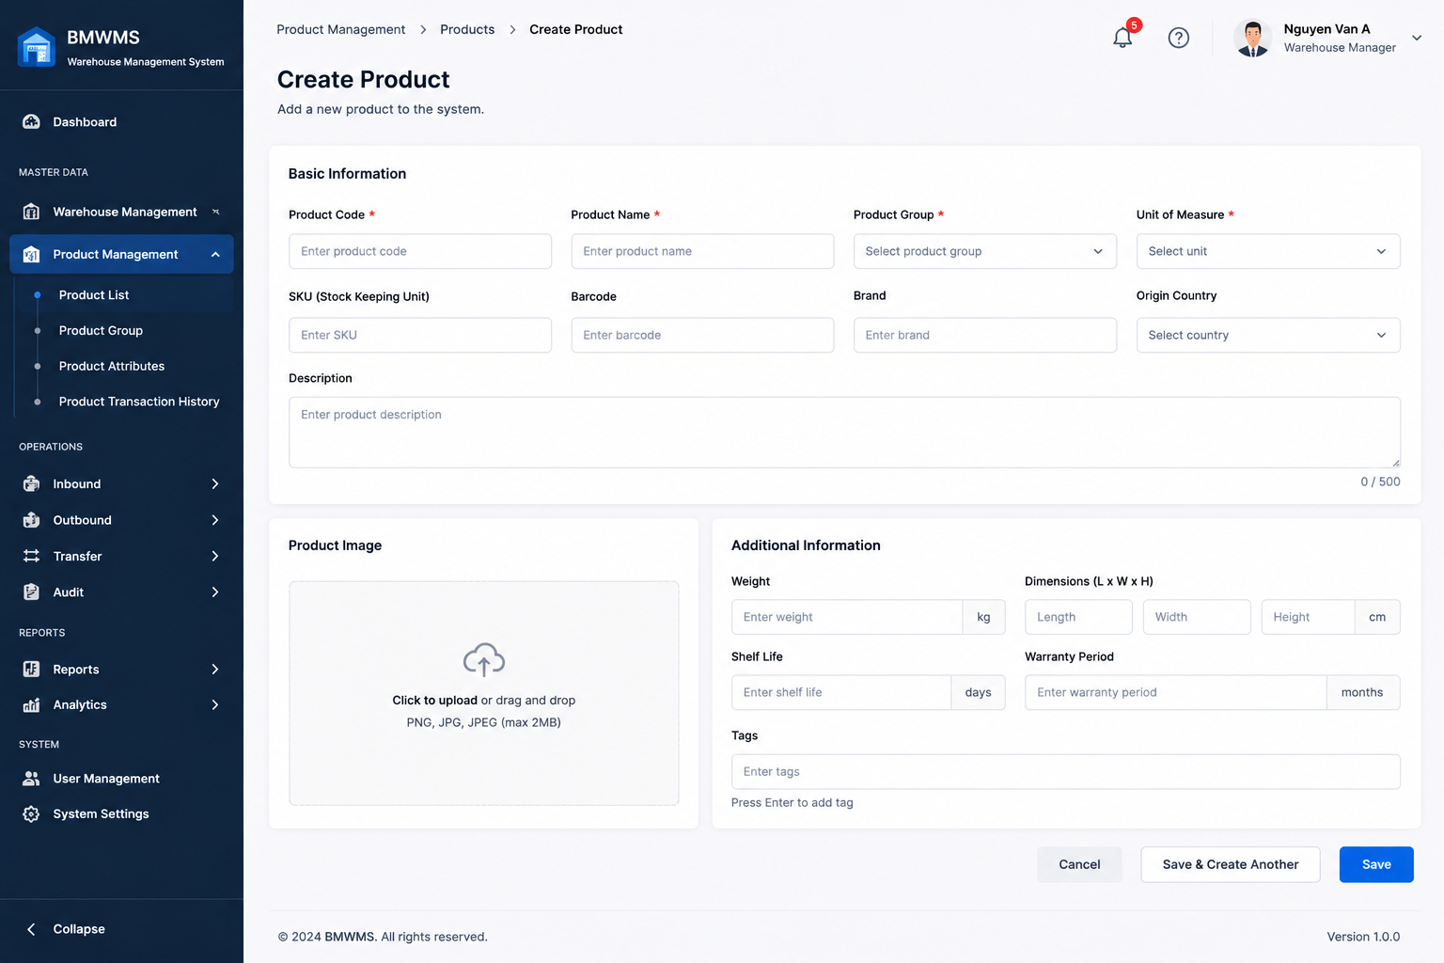

Field | Value
Type | UI
Primary Actor | Warehouse Manager
Secondary Actor(s) | System Administrator
Module | Product Management
FT-ID Ref | F02.01
Depends On | UC-16 View Product Group List
Preconditions | User is logged in and has permission to create products. At least one active Product Group exists.
Postconditions | A new product is created and available for warehouse operations.

Main Flow
- [U] User opens the Product List screen.
- [U] User clicks Create Product.
- [S] System displays the Create Product form.
- [U] User enters product information, pricing information, supplier information, inventory settings, and barcode information.
- [U] User uploads a product image (optional).
- [U] User clicks Save.
- [S] System validates the input — see BR-01, BR-02, BR-03.
- [S] System creates a new Product record.
- [S] System creates barcode information for the product.
- [S] System stores product image information if provided.
- [S] System records creation date and creator information.
- [S] System displays a success message.
- [S] System redirects the user to the Product Detail screen.

Alternative Flows
AF-01 — Duplicate Product Code

At step 7, the Product Code already exists.

The product is not created.

The user remains on the form and sees:

"Product Code already exists."

AF-02 — Duplicate Barcode

At step 7, the Barcode already belongs to another product.

The product is not created.

The user remains on the form and sees:

"Barcode already exists."

AF-03 — Required Information Missing

At step 7, one or more mandatory fields are empty.

The product is not created.

The system highlights invalid fields and displays validation messages.

AF-04 — Invalid Image File

At step 5, the uploaded file format is not supported.

The product is not created.

The system displays:

"Invalid image format."
AF-05 — User Cancels Creation

At step 6, the user selects Cancel.

The system discards all unsaved information and returns to the Product List screen.

Business Rules
BR-01

Product Code must be unique across the system.

BR-02

Product Name, Product Code, Product Group, and Unit of Measure are required.

BR-03

Barcode must be unique across the system.

BR-04

Standard Cost and Sale Price must be greater than or equal to zero.

BR-05

Only active Product Groups can be assigned to a product.

BR-06

Only active Suppliers can be assigned as preferred suppliers.

BR-07

New products are created with status Active by default.

BR-08

The system shall automatically record creation date and creator information.

Request Fields — Create Product Request
Field | Type | Rule
Product Code | Text | Required. Unique. Maximum 50 characters.
Product Name | Text | Required. Maximum 255 characters.
Product Group | Text | Required. Must be active.
Description | Text | Optional. Maximum 2000 characters.
Unit of Measure | Text | Required.
Barcode | Text | Required. Unique.
Brand | Text | Optional.
Origin Country | Text | Optional.
Standard Cost | Number | Required. Greater than or equal to 0.
Sale Price | Number | Required. Greater than or equal to 0.
Preferred Supplier | Text | Optional. Must be active.
Safety Stock | Number | Optional. Greater than or equal to 0.
Reorder Level | Number | Optional. Greater than or equal to 0.
Product Image | File | Optional. JPG, PNG supported.

On success: The product is created successfully and displayed on the Product Detail screen.

Allowed Roles
- Warehouse Manager
- System Administrator

Verification Criteria
Given
- The user is logged in
- At least one active Product Group exists
- The user has product creation permission
When
- The user submits valid product information
Then
- A new product record is created
- Barcode information is created
- Product status is Active
- Creator information is recorded
- Product appears in the Product List
Additional scenarios to cover in tests:
- Create product with valid information.
- Create product with image upload.
- Create product using an existing Product Code.
- Create product using an existing Barcode.
- Create product without Product Name.
- Create product without Product Group.
- Create product with invalid image format.
- Create product with inactive Product Group.
- Cancel creation before saving.
- Verify product appears in Product List after creation.

UC-13: Manage Product Attributes
UI-type block
Copy this block for each UI-type use case. Sections: Header | Main Flow | Alternative Flows | Business Rules | Request Fields | Allowed Roles | Verification Criteria
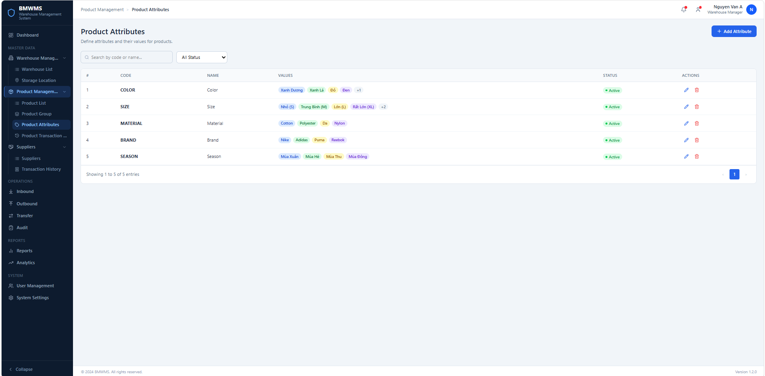
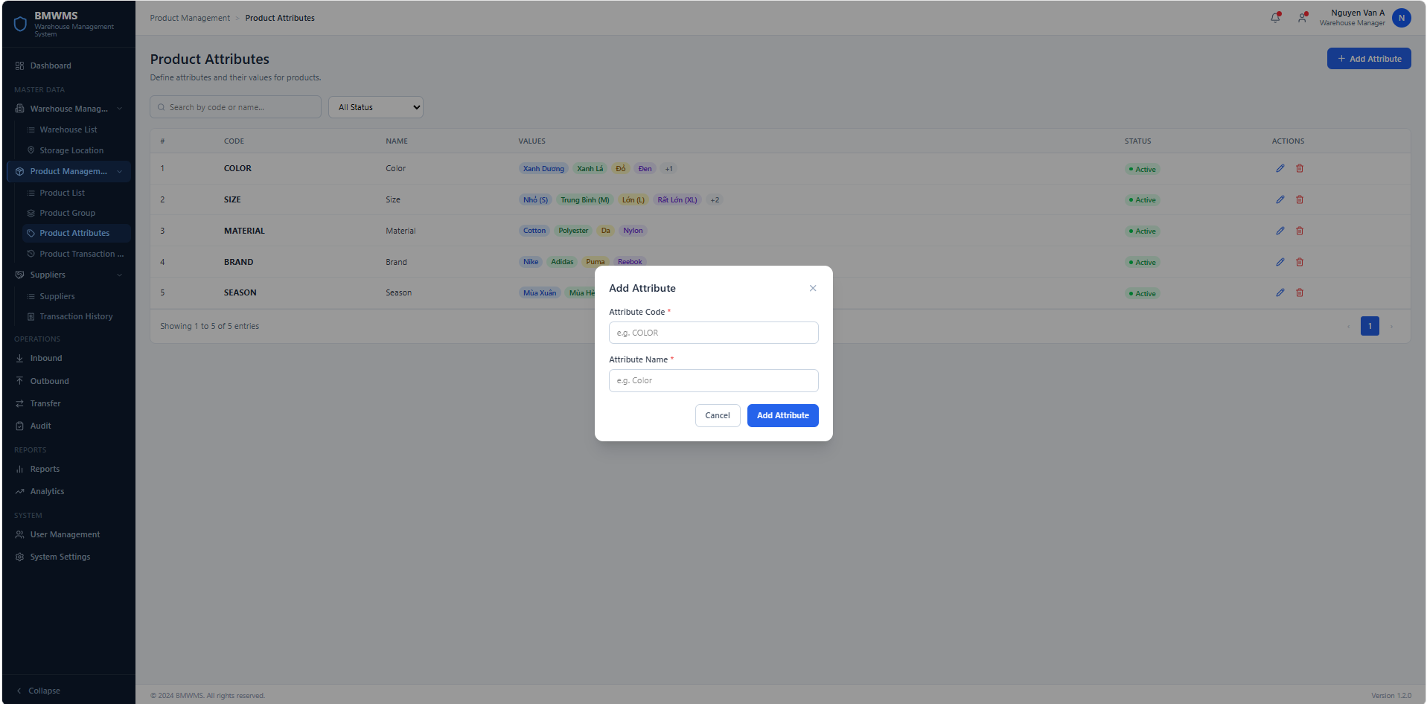
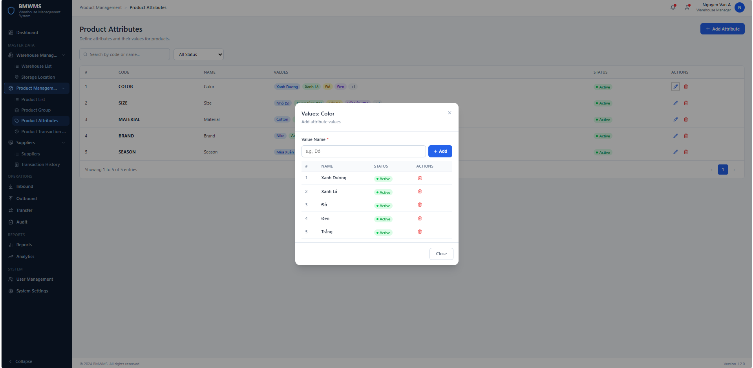

Field | Value
Type | UI
Primary Actor | Warehouse Manager
Secondary Actor(s) | System Administrator
Module | Product Management
FT-ID Ref | F02.03
Depends On | UC-12 Manage Product Groups
Preconditions | User is logged in and has permission to manage Product Attributes.
Postconditions | A Product Attribute is created and available to be assigned to one or more Product Groups.

Main Flow
- [U] User opens the Product Attributes screen.
- [S] System displays the Product Attribute List.
- [U] User clicks Add Attribute.
- [S] System displays the Add Attribute popup.
- [U] User enters Attribute Code and Attribute Name.
- [U] User clicks Add Attribute.
- [S] System validates the input (see BR-01 and BR-02).
- [S] System creates the Product Attribute.
- [S] System displays the newly created Product Attribute.
- [U] User opens the Attribute Values popup.
- [U] User adds one or more predefined Attribute Values.
- [S] System validates each Attribute Value (see BR-03).
- [S] System stores the Attribute Values.
- [S] The Product Attribute becomes available for assignment to Product Groups.

Alternative Flows
AF-01 — Duplicate Attribute Code

At step 7, the Attribute Code already exists.

The Product Attribute is not created.

The user remains on the Add Attribute popup and sees:

"Attribute Code already exists."

AF-02 — Required Information Missing

At step 7, one or more required fields are empty.

The Product Attribute is not created.

The system highlights the missing fields and displays validation messages.

AF-03 — Duplicate Attribute Value

At step 12, the entered Attribute Value already exists within the selected Product Attribute.

The Attribute Value is not created.

The system displays:

"Attribute Value already exists."

AF-04 — Product Attribute Is In Use

The user attempts to delete or deactivate a Product Attribute that is currently assigned to one or more Product Groups.

The operation is rejected.

The system displays:

"This Product Attribute is assigned to one or more Product Groups and cannot be deleted or deactivated."

AF-05 — Empty Attribute Value

At step 11, the user clicks Add without entering a Value Name.

The Attribute Value is not created.

The system displays:

"Attribute Value is required."

AF-06 — User Cancels

The user clicks Cancel or closes the popup before saving.

The system discards all unsaved information and returns to the Product Attribute List.

Business Rules
BR-01

Attribute Code must be unique across the system.

BR-02

Attribute Code and Attribute Name are required.

BR-03

Attribute Values must be unique within the same Product Attribute.

BR-04

One Product Attribute may contain multiple predefined Attribute Values.

BR-05

A Product Attribute may be assigned to multiple Product Groups.

BR-06

Products do not receive Product Attributes directly. Product Attributes are inherited through the assigned Product Group.

BR-07

A Product Attribute assigned to one or more Product Groups cannot be deleted.

BR-08

New Product Attributes are created with Active status by default.

Request Fields
Field | Type | Rule
Attribute Code | Text | Required. Unique. Maximum 50 characters.
Attribute Name | Text | Required. Maximum 255 characters.
On success: The Product Attribute is created successfully and displayed in the Product Attribute List.

Field | Type | Rule
Value Name | Text | Required. Maximum 100 characters. Unique within the selected Product Attribute.
On success: The Attribute Value is added successfully and displayed in the Attribute Values popup.

Field | Type | Rule
Attribute Code | Text | Required. Unique. Maximum 50 characters.
Attribute Name | Text | Required. Maximum 255 characters.
On success: The Product Attribute is created successfully and displayed in the Product Attribute List.

Response Fields
Field | Type | Rule
Attribute ID | UUID | System generated. Hidden.
Attribute Code | Text | Display only.
Attribute Name | Text | Display only.
Attribute Values | Array<String> | Display predefined values. Show the first few values and display "+N" if more values exist.
Status | Text | Active or Inactive.

Allowed Roles
- Warehouse Manager
- System Administrator

Verification Criteria
Given
- The user is logged in.
- The user has permission to manage Product Attributes.
When
The user creates a new Product Attribute and optionally adds predefined Attribute Values.
Then
- A new Product Attribute record is created.
- Product Attribute status is Active by default.
- Attribute Values are created successfully.
- Creator information is recorded.
- Product Attribute appears in the Product Attribute List.
- The Product Attribute becomes available for assignment to Product Groups.

Additional scenarios to cover in tests:

- Create a Product Attribute with valid information.
- Create a Product Attribute using an existing Attribute Code.
- Create a Product Attribute without an Attribute Code.
- Create a Product Attribute without an Attribute Name.
- Add an Attribute Value successfully.
- Add a duplicate Attribute Value.
- Add an empty Attribute Value.
- Delete an Attribute Value.
- Edit a Product Attribute.
- Deactivate an unused Product Attribute.
- Attempt to delete or deactivate a Product Attribute assigned to one or more Product Groups.
- Search Product Attributes by Code or Name.
- Filter Product Attributes by Status.
- Verify the Product Attribute appears in the Product Attribute List after creation.
- Verify the Product Attribute can be assigned to a Product Group.

UC-14: Manage Product Barcodes
UI-type block
Copy this block for each UI-type use case. Sections: Header | Main Flow | Alternative Flows | Business Rules | Request Fields | Allowed Roles | Verification Criteria

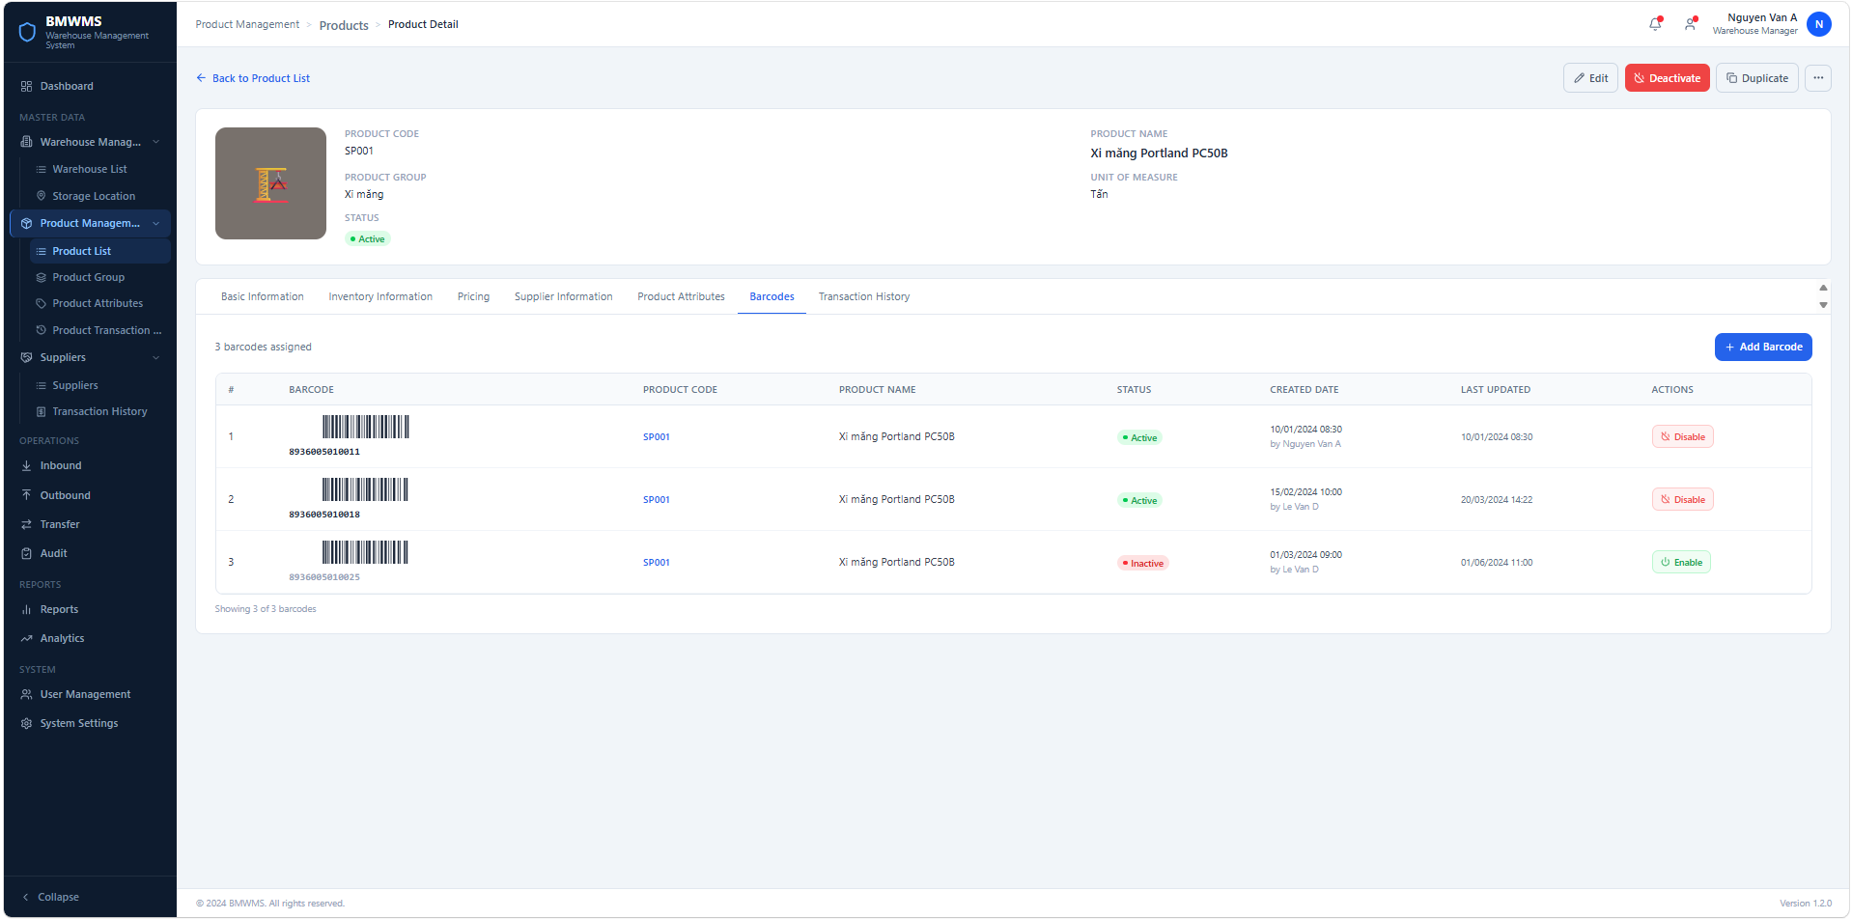

Field | Value
Type | UI
Primary Actor | Warehouse Manager
Secondary Actor(s) | System Administrator
Module | Product Management
FT-ID Ref | F02.04
Depends On | UC-10 Manage Products
Preconditions | User is logged in and has permission to manage Product Barcodes. At least one active Product exists.
Postconditions | Barcode information is created or updated successfully and is available for product identification and warehouse operations.

Main Flow
- [U] User opens the Product Detail screen.
- [U] User selects the Barcode section.
- [U] User clicks Add Barcode.
- [S] System displays the Add Barcode form.
- [U] User enters barcode information or scans a barcode.
- [U] User clicks Save.
- [S] System validates the barcode information (see BR-01, BR-02).
- [S] System creates the barcode record.
- [S] System links the barcode to the selected Product.
- [S] System records creation date and creator information.
- [S] System displays a success message.
- [S] System refreshes the Barcode List.

Alternative Flows
AF-01 — Duplicate Barcode

At step 7, the Barcode already exists.

The barcode is not created.

The system displays:

"Barcode already exists."

AF-02 — Required Information Missing

At step 7, required information is missing.

The barcode is not created.

The system highlights invalid fields and displays validation messages.

AF-03 — Invalid Barcode Format

At step 7, the Barcode format is invalid.

The barcode is not created.

The system displays:

"Invalid barcode format."

AF-04 — Product Is Inactive

At step 7, the selected Product is inactive.

The barcode is not created.

The system displays:

"Barcode cannot be assigned to an inactive product."

AF-05 — User Cancels

At step 6, the user clicks Cancel.

The system discards all unsaved information and returns to the Product Detail screen.

Business Rules
BR-01

Barcode must be unique across the system.

BR-02

Barcode is required.

BR-03

Each Barcode must be assigned to exactly one Product.

BR-04

A Product may have multiple Barcodes.

BR-05

Inactive Products cannot receive new Barcodes.

BR-06

Disabled Barcodes cannot be used during warehouse operations.

BR-07

The system shall automatically record creation date and creator information.

Request Fields - Create Product Barcode Request
Field | Type | Rule
Barcode | Text | Required. Unique. Maximum 100 characters.
Product | Reference | Required. Must be an active Product.
On success: The Barcode is created successfully and linked to the selected Product.

Response Fields
Field | Type | Rule
Barcode | Text | Display only.
Product Code | Text | Display only.
Product Name | Text | Display only.
Status | Text | Active or Disabled.
Created Date | DateTime | Display only.
Last Updated | DateTime | Display only.

Allowed Roles
- Warehouse Manager
- System Administrator

Verification Criteria
Given
- The user is logged in.
- The user has permission to manage Product Barcodes.
- At least one active Product exists.
When
The user submits valid barcode information.
Then
- A new Barcode record is created.
- The Barcode is linked to the selected Product.
- Barcode status is Active.
- Creator information is recorded.
- The Barcode appears in the Product Detail screen.
Additional scenarios to cover in tests:

- Create a Barcode with valid information.
- Create a Barcode using an existing Barcode.
- Create a Barcode without Barcode information.
- Create a Barcode for an inactive Product.
- Create a Barcode with an invalid format.
- Cancel barcode creation before saving.
- Verify the Barcode appears in the Product Detail screen after creation.
- Verify multiple Barcodes can be assigned to the same Product.
- Verify one Barcode cannot be assigned to multiple Products.

